New pressure transmitter with
CANopen® and J1939 protocols

Klingenberg, November 2012.
With the model MHC-1, WIKA has launched a new pressure transmitter for mobile hydraulic applications onto the market, which is available with CANopen® and J1939 output signals.

In mobile hydraulics, the MHC-1 is exposed to extreme operating conditions. To ensure its long-term reliability, all requirement parameters were simulated in a specific test programme. The robust instrument has been designed to be very durable, is intended for measuring ranges from 0 ... 60 to 0 ... 1,000 bar, and offers an accuracy to < 0.5 % of span. MHC-1 has excellent temperature characteristics and with high EMC protection is particularly immune to interferences.

For ease of installation, it can be ordered preconfigured. The version with an integrated Y-connector enables an installation that is as safe as it is easy.

Number of characters: 893
Key words: Pressure transmitter MHC-1

Manufacturer:
WIKA Alexander Wiegand SE & Co. KG
Alexander-Wiegand-Straße 30
63911 Klingenberg/Germany
Tel. +49 (0)9372 1320
Fax +49 (0)9372 132406
sales@wika.de
www.wika.com

WIKA company photograph:
New pressure transmitter with CANopen® and J1939 protocols

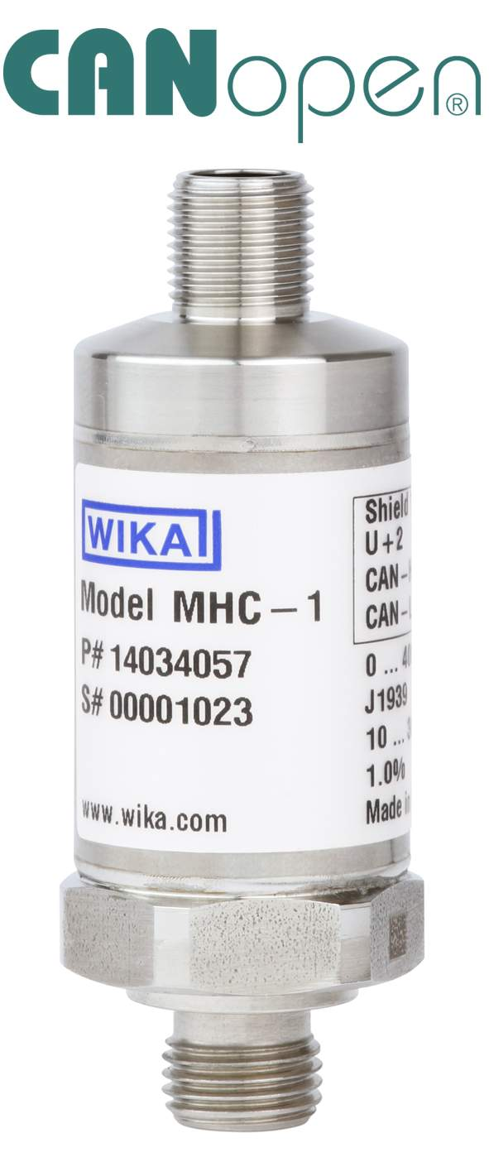

Edited by:
WIKA Alexander Wiegand SE & Co. KG
André Habel Nunes
Marketing Services
Alexander-Wiegand-Straße 30
63911 Klingenberg/Germany
Tel. +49 (0)9372 132-8010
Fax +49 (0)9372 132-8008010
a.habel-nunes@wika.de
www.wika.com

WIKA press release 25/2012

