New digital controllers for
general application

Klingenberg, October 2012.
WIKA has now completed its portfolio of temperature controllers with two digital instruments for simple thermostat applications: The model SC58 and model SC64 close the gaps in this segment between mechanical products and complex PID instruments.

The new digital controllers are designed for a measuring range of -80 to +400 °C, and can therefore be used universally. The switch hysteresis can be set via the menu, which assists the flexibility. Both two-point controllers are equally notable for their high switching accuracy and contact rating (16 A). They are easy to use and offer a highly-visible display (13 mm high characters).

The SC58 and SC64 have the same design as the corresponding mechanical and mechatronic controllers. Users can therefore change to the digital instrument without any additional expense.

Number of characters: 890
Key words: Digital controllers SC58 and SC64

Manufacturer:
WIKA Alexander Wiegand SE & Co. KG
Alexander-Wiegand-Straße 30
63911 Klingenberg/Germany
Tel. +49 (0)9372 1320
Fax +49 (0)9372 132406
sales@wika.de
www.wika.com

WIKA company photograph:
Digital controllers SC58 and SC64

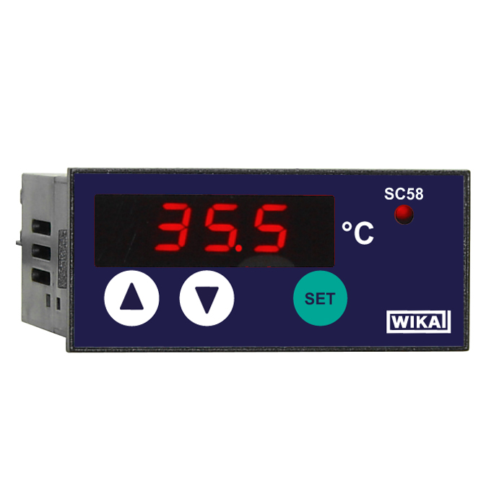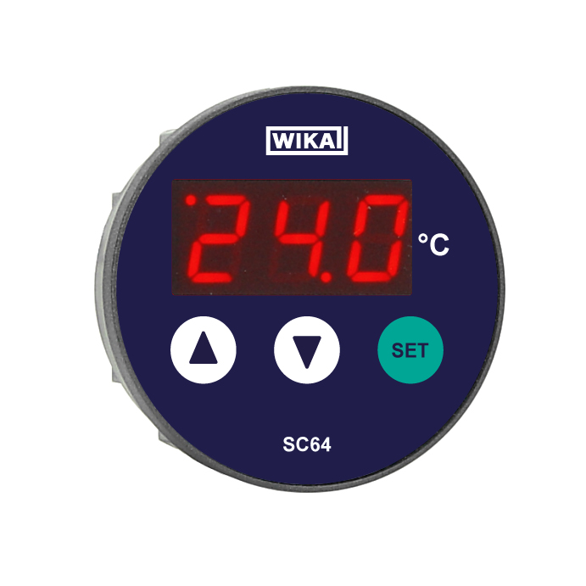

Edited by:
WIKA Alexander Wiegand SE & Co. KG
André Habel Nunes
Marketing Services
Alexander-Wiegand-Straße 30
63911 Klingenberg/Germany
Tel. +49 (0)9372 132-8010
Fax +49 (0)9372 132-8008010
a.habel-nunes@wika.de
www.wika.com

WIKA press release 24/2012

