Information brochure for the chemical industry

Klingenberg, July 2012.
A new information brochure from WIKA is aimed at companies in the chemical and petrochemical industries. It has been published to coincide with the ACHEMA trade show.

All relevant facts regarding instrumentation for pressure, temperature and level for the chemical industry have been packed into the booklet. The brochure deals in detail with the high demands on materials, approvals, explosion protection and functional safety. The information is complemented by a broad product overview - from pressure gauges through temperature measuring points to level indicators. Illustrations of the equipment combinations show how much versatility is possible.

The new information brochure can be ordered by E-mail (info@wika.de). It is also available for download from the website www.wika.com.

Number of characters: 854
Key words: Brochure "Chemical and petrochemical industries"

Manufacturer:
WIKA Alexander Wiegand SE & Co. KG
Alexander-Wiegand-Straße 30
63911 Klingenberg/Germany
Tel. +49 (0)9372 1320
Fax +49 (0)9372 132406
sales@wika.de
www.wika.com

WIKA company photograph:
Brochure "Chemical and petrochemical industries"

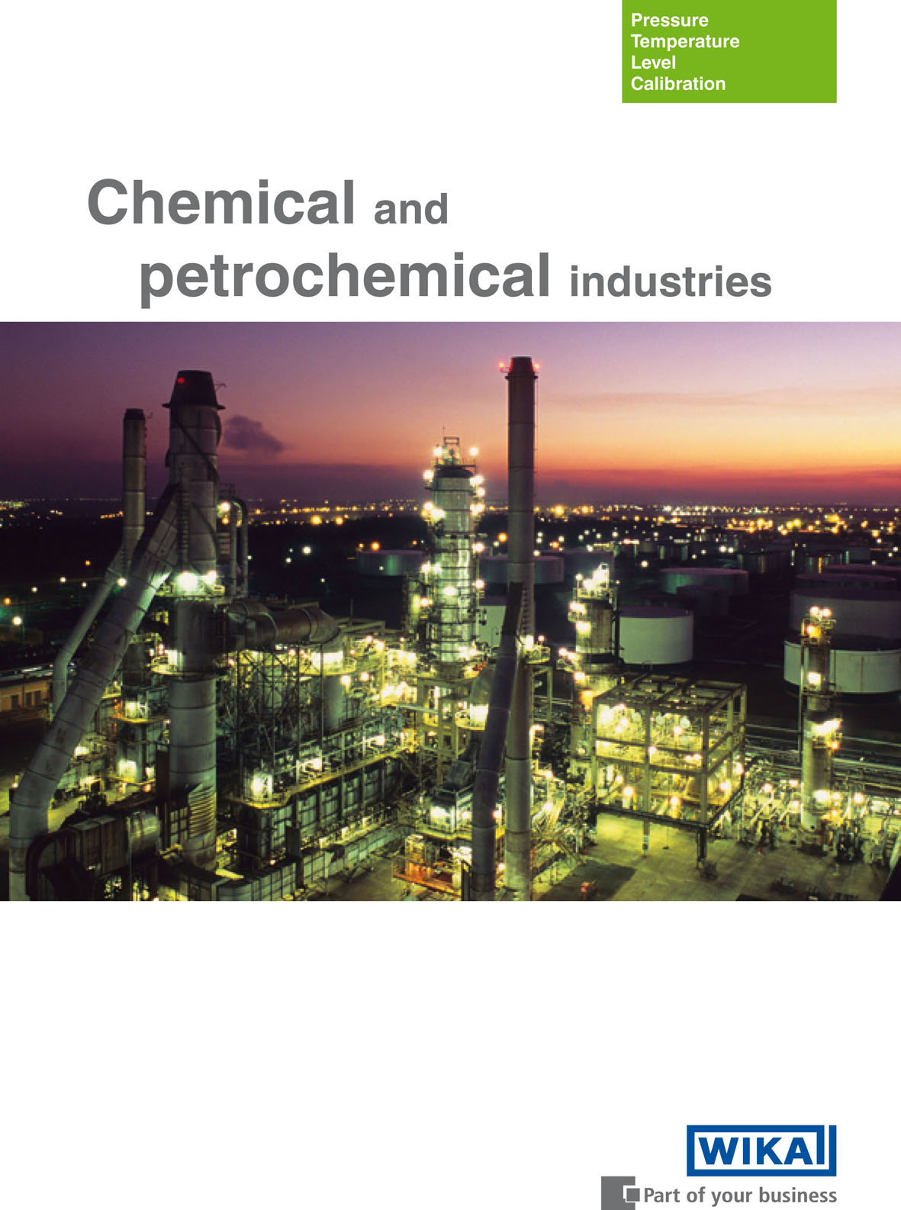

Edited by:
WIKA Alexander Wiegand SE & Co. KG
André Habel Nunes
Marketing Services
Alexander-Wiegand-Straße 30
63911 Klingenberg/Germany
Tel. +49 (0)9372 132-8010
Fax +49 (0)9372 132-8008010
a.habel-nunes@wika.de
www.wika.com

WIKA press release 18/2012

