Top marks for WIKA
at the annual Hoppenstedt credit rating

Klingenberg, June 2012.
WIKA's financial stability has been awarded the credit rating index of 1 by Hoppenstedt Kreditinformationen GmbH.
Only 4.4 % of all German companies have been awarded this "Top Rating" by the recognised credit rating agency.

The nationally recognised "CreditCheck" underlines WIKA's healthy financial structure with a solid equity position. This was one of the main reasons that the company was able to successfully cope with the recent economic crisis. The Hoppenstedt rating is based on the demographic and financial data of companies, as well as information on their payment history.

Number of characters: 670
Key words: Hoppenstedt Top Rating

Manufacturer:
WIKA Alexander Wiegand SE & Co. KG
Alexander-Wiegand-Straße 30
63911 Klingenberg/Germany
Tel. +49 (0)9372 1320
Fax +49 (0)9372 132406
sales@wika.de
www.wika.com

WIKA company photograph:
Top marks for WIKA at the annual Hoppenstedt credit rating

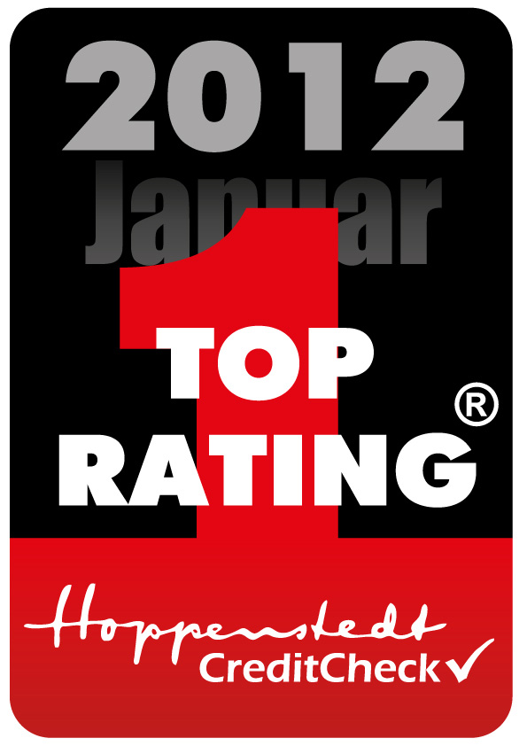

Edited by:
WIKA Alexander Wiegand SE & Co. KG
André Habel Nunes
Marketing Services
Alexander-Wiegand-Straße 30
63911 Klingenberg/Germany
Tel. +49 (0)9372 132-8010
Fax +49 (0)9372 132-8008010
a.habel-nunes@wika.de
www.wika.com

WIKA press release 16/2012

