Miniature resistance thermometer
gets ATEX and IECEx approval

Klingenberg, November 2014.
The safety-related quality of the new TR34 miniature resistance thermometer from WIKA is confirmed: The instrument has been awarded ATEX and IECEx approval for Ex-i ignition protection type by DEKRA Exam GmbH.

The TR34 expands the new programme of miniature resistance thermometers to add a measuring instrument with an intrinsically safe design, geared to a wide variety of applications. High-quality materials, high vibration resistance and ingress protection to IP 67 and 69K make the TR34 extremely durable.

The new miniature resistance thermometers are screwed directly into the process. They feature an integrated digital transmitter with a measuring range of -50 … +250 °C, which can be programmed individually and simply via newly developed software.

Number of characters: 845
Key words: TR34 with Ex approval

Manufacturer:
WIKA Alexander Wiegand SE & Co. KG
Alexander-Wiegand-Straße 30
63911 Klingenberg/Germany
Tel. +49 9372 132-0
Fax +49 9372 132-406
vertrieb@wika.com
www.wika.com

WIKA company photograph:
WIKA miniature thermometer TR34 with ATEX and IECEx approval

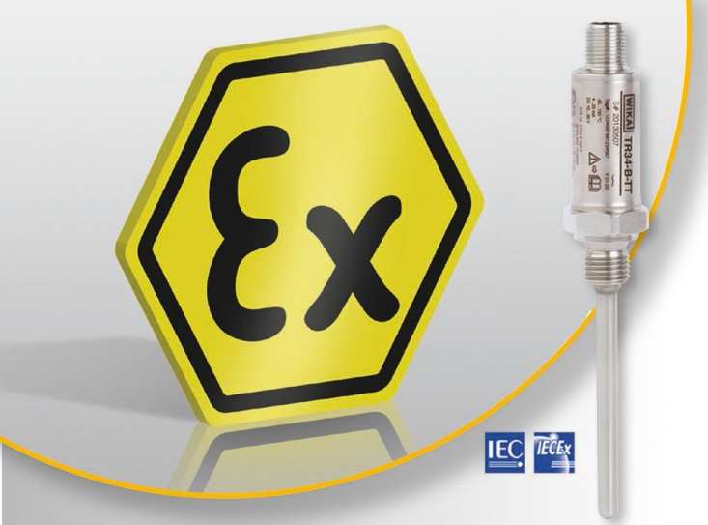

Edited by:
WIKA Alexander Wiegand SE & Co. KG
André Habel Nunes
Marketing Services
Alexander-Wiegand-Straße 30
63911 Klingenberg/Germany
Tel. +49 9372 132-8010
Fax +49 9372 132-8008010
andre.habel-nunes@wika.com
www.wika.com

WIKA press release 10/2014

