Hastelloy pressure gauge for
highly aggressive media

Klingenberg, June 2020. For pressure measurement in processes with highly aggressive media, WIKA has a new Bourdon tube pressure gauge in its portfolio, the model PG28. The wetted parts are made of Hastelloy C276 and are even resistant to chlorine gas, hydrofluoric acid and sulphuric acid.

Users therefore have a corrosion-resistant measuring solution with a very good price/performance ratio that also requires little installation space. The model PG28 is available with scale ranges from 0 … 0.6 bar to 0 … 700 bar. Its case (nominal sizes 100 and 160) is optionally available with filling and in an “S3” safety version. Other instrument variants are suitable for ATEX and NACE sour gas applications.

The model PG28 extends the existing Hastelloy product range with diaphragm pressure gauges and diaphragm seals. WIKA thus offers the right solution for every possible application in the field of mechanical pressure measurement.

Number of characters: 905
Key word: PG28

Manufacturer:
WIKA Alexander Wiegand SE & Co. KG
Alexander-Wiegand-Straße 30
63911 Klingenberg/Germany
Tel. +49 9372 132-0
Fax +49 9372 132-406
vertrieb@wika.com
www.wika.de

WIKA company photograph:
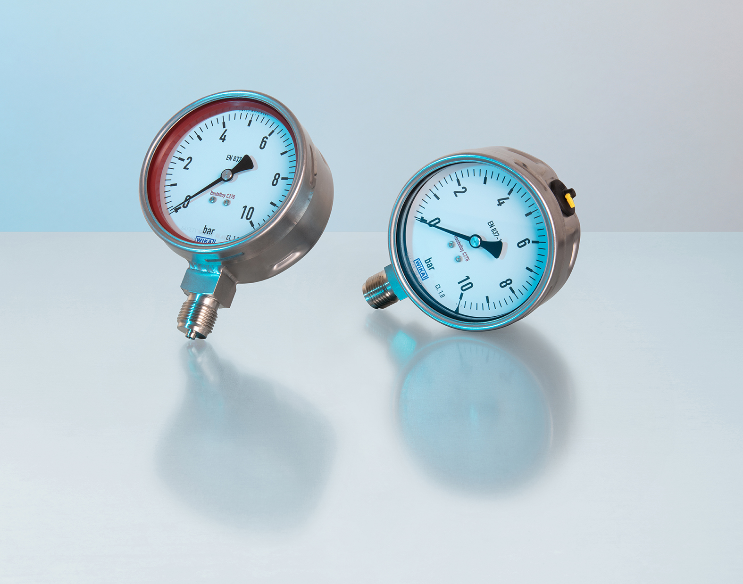
Typ: PG28

Edited by:
WIKA Alexander Wiegand SE & Co. KG
André Habel Nunes
Marketing Services
Alexander-Wiegand-Straße 30
63911 Klingenberg/Germany
Tel. +49 9372 132-8010
andre.habel-nunes@wika.com
www.wika.de

WIKA press release

