New calibration service
for length measuring equipment

Klingenberg, August 2018.
WIKA is offering a new manufacturer-independent calibration service: Besides instruments for the measurands pressure, temperature and current/voltage/resistance, the laboratory of the company now also tests length measuring equipment on behalf of customers.

The offer comprises all conventional measuring test equipment and reference gauges as well as special reference gauges according to customer drawings. For tapered thread gauges for the control of process connections, the service goes beyond the standard good-bad test: In accordance with ANSI/ASME standard, the WIKA laboratory determines the actual dimensions of the pitch diameter of the reference gauge. The findings allow a conclusion to be drawn about the wear and tear of the instrument and consequently the development of accuracy.

The calibration of length measuring equipment is confirmed with a 3.1 test report. Every order includes an adjustment if this is necessary and possible. An express service is available on request.

Number of characters: 997
Key word: Calibration service for length measuring equipment

Manufacturer:
WIKA Alexander Wiegand SE & Co. KG
Alexander-Wiegand-Straße 30
63911 Klingenberg/Germany
Tel. +49 9372 132-0
Fax +49 9372 132-406
vertrieb@wika.com
www.wika.de

WIKA company photograph:
New calibration service for length measuring equipment

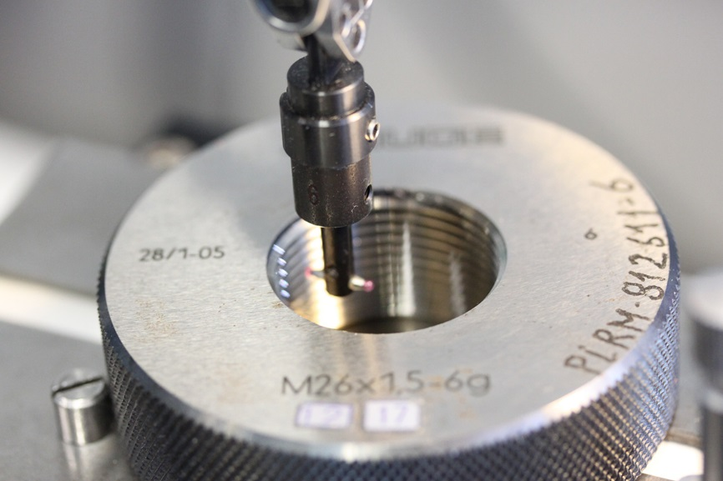

Edited by:
WIKA Alexander Wiegand SE & Co. KG
André Habel Nunes
Marketing Services
Alexander-Wiegand-Straße 30
63911 Klingenberg/Germany
Tel. +49 9372 132-8010
Fax +49 9372 132-8008010
andre.habel-nunes@wika.com
www.wika.de

WIKA press release 9/2018

