High-temperature thermocouple
with additional protection from sapphire glass

Klingenberg, May 2017.
The new TC84 high-temperature thermocouple from WIKA features the highest safety and a long service life. Its resilience is based on a sapphire protection tube in combination with a two-stage safety chamber. The measuring instrument is also available in an ATEX and also an IECEx certified version.

Typical applications for the TC84 are gasification reactors with process temperatures up to 1700 °C and pressure loads up to 65 bar or sulphur recovery units. In the patented design of the measuring instrument, the precious-metal thermocouple is shielded from damaging process influences through two protection tubes - through an external tube from ceramic and an internal tube from monocrystalline sapphire glass, which effectively delays the poisoning of the thermocouple. In the event of any failure, the dual sealing system of the safety chamber prevents the escape of toxic media.

The construction of the thermocouple also follows economical principles. A TC84, damaged following extreme loading, can be repaired through the exchange of the wetted parts; a completely new purchase is therefore not required. The sapphire protection tube also eliminates the need for expensive purging with inert gas, for example, to protect the thermocouple.

Number of characters: 1244
Key word: TC84

Manufacturer:
WIKA Alexander Wiegand SE & Co. KG
Alexander-Wiegand-Straße 30
63911 Klingenberg/Germany
Tel. +49 9372 132-0
Fax +49 9372 132-406
vertrieb@wika.com
www.wika.com

WIKA company photograph:
The new TC84 high-temperature thermocouple from WIKA features the highest safety and a long service life.

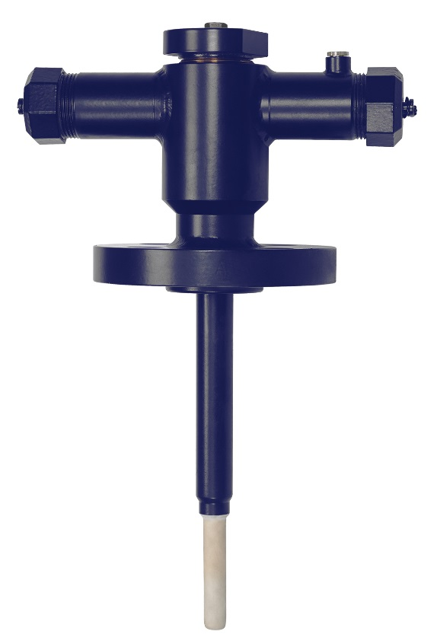

Edited by:
WIKA Alexander Wiegand SE & Co. KG
André Habel Nunes
Marketing Services
Alexander-Wiegand-Straße 30
63911 Klingenberg/Germany
Tel. +49 9372 132-8010
Fax +49 9372 132-8008010
andre.habel-nunes@wika.com
www.wika.com

WIKA press release 09/2017

