OEM float switch
in miniature design
Klingenberg, April 2019.
WIKA now offers OEM manufacturers a miniature float switch. The model RLS-7000/8000 has one switch point and is particularly suitable for level monitoring in small tanks.

The performance and design of the float switch meet the requirement of original equipment manufacturers for reliable as well as economical components. In addition to the standard version, design-in solutions are also possible: The model RLS-7000/8000 can be adapted to the respective application through customisation of designs, tank connections and electrical connections. The switch can be installed vertically (RSL-7000) or horizontally (RSL-8000). Its switching function, normally open or normally closed, can be reversed by rotating the float body (RLS-7000) or the complete instrument (RLS-8000) through 180°.

The new float switch has been designed for a long service life. The instrument is available in a variety of robust and chemically resistant plastics with very low water absorption. Its reed contacts provide up to a billion switching cycles, depending on the application.

Number of characters: 1058
Key word: RLS-7000/-8000

Manufacturer:
WIKA Alexander Wiegand SE & Co. KG
Alexander-Wiegand-Straße 30
63911 Klingenberg/Germany
Tel. +49 9372 132-5049
Fax +49 9372 132-406
vertrieb@wika.com
www.wika.de

WIKA company photograph:
WIKA now offers OEM manufacturers a miniature float switch
model RLS-7000/8000

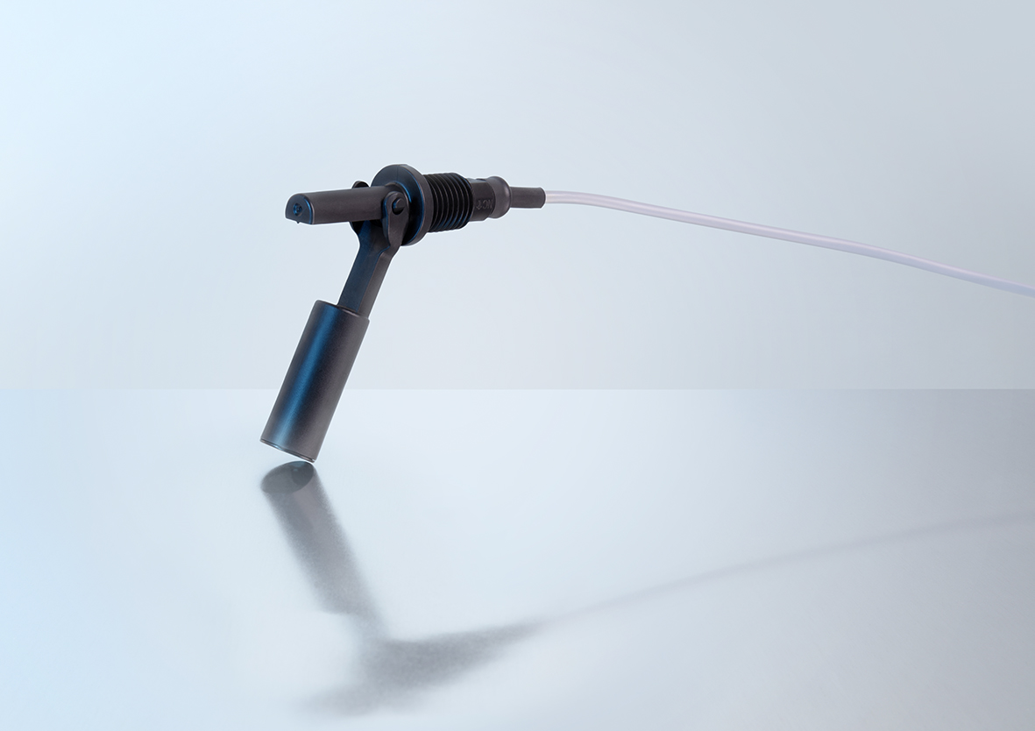

Edited by:
WIKA Alexander Wiegand SE & Co. KG
André Habel Nunes
Marketing Services
Alexander-Wiegand-Straße 30
63911 Klingenberg/Germany
Tel. +49 9372 132-8010
Fax +49 9372 132-8008010
andre.habel-nunes@wika.com
www.wika.de

WIKA press release 04/2019

