New pressure transmitter for hazardous areas

Klingenberg, February 2015.
For use in hazardous applications worldwide, WIKA has launched a new pressure transmitter to the market. The model IS-3 features a combined ATEX and IECEx approval as well as a SIL 2 rating.

In addition to its suitability for operation in Ex areas, the IS-3 offers a wide range of variants. It is available with measuring ranges up to 6,000 bar and operates with an accuracy of up to 0.25 % of span.

A variety of process connections, and also an optional field case, increase the versatility of this new pressure transmitter. The IS-3 is also available in versions with a flush diaphragm, for measuring viscous or contaminated media, and with a pressure port, for gas and hydraulic applications.

Number of characters: 765
Key word: IS-3

Manufacturer:
WIKA Alexander Wiegand SE & Co. KG
Alexander-Wiegand-Straße 30
63911 Klingenberg/Germany
Tel. +49 9372 132-0
Fax: +49 9372 132-406
vertrieb@wika.com
www.wika.com

WIKA company photographs:
Pressure transmitter IS-3

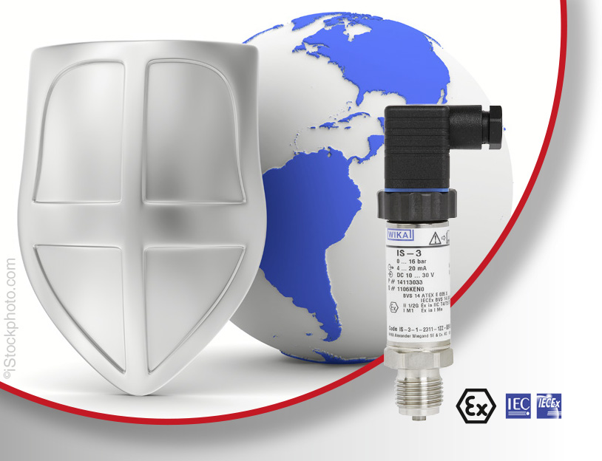

Edited by:
WIKA Alexander Wiegand SE & Co. KG
André Habel Nunes
Marketing Services
Alexander-Wiegand-Straße 30
63911 Klingenberg/Germany
Tel. +49 9372 132-8010
Fax: +49 9372 132-8008010
andre.habel-nunes@wika.com
www.wika.com

WIKA press release 04/2015

