New hand-held thermometer
for general application

Klingenberg, April 2013.
The new CTH6300 hand-held thermometer from WIKA is flexible in operation and, at the same time, value-for-money. The fast-acting instrument operates with an accuracy of up to 0.1 K over the complete measuring chain.

The portable thermometer can be combined with Pt100 resistance thermometers and all established sensor types. It therefore covers a range from -200 °C to 1,500 °C. The CTH6300 is easy to use, with a large display and min/max memory, and is also available in a two-channel version. It is equally suited to temperature measurement and also calibration tasks. Customers can order the hand-held with a DKD/DakkS certificate.

With this new instrument, WIKA has delivered a uniform "look and feel" for the product family. Accessories have also been matched appropriately. There is also a service case available for the CTH6300.

Number of characters: 908
Key word: CTH6300

Manufacturer:
WIKA Alexander Wiegand SE & Co. KG
Alexander-Wiegand-Straße 30
63911 Klingenberg/Germany
Tel. +49 9372 1320
Fax +49 9372 132406
vertrieb@wika.com
www.wika.com

WIKA company photograph:
Hand-held thermometer CTH6300

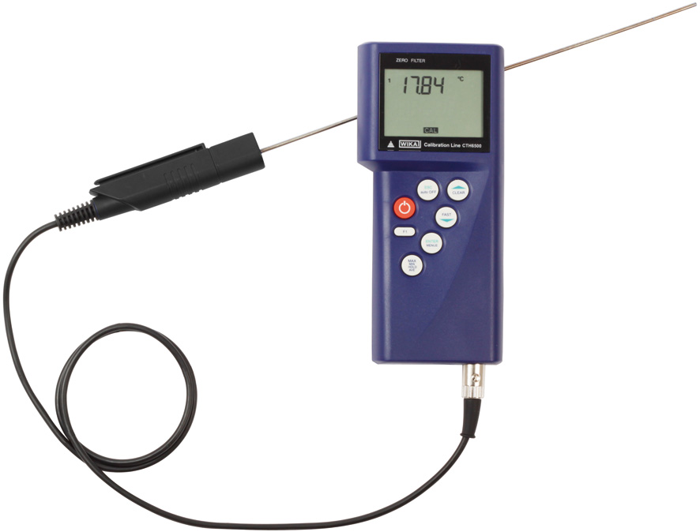

Edited by:
WIKA Alexander Wiegand SE & Co. KG
André Habel Nunes
Marketing Services
Alexander-Wiegand-Straße 30
63911 Klingenberg/Germany
Tel. +49 9372 132-8010
Fax +49 9372 132-8008010
andre.habel-nunes@wika.com
www.wika.com

WIKA press release 04/2013

