AEO certificate guarantees security in the delivery chain

Klingenberg, March 2012.
The main customs office in Schweinfurt has certified WIKA as an "Authorised Economic Operator" (AEO). This will guarantee a secure delivery chain for export customers and accelerated exports.

After a two-day inspection by the customs authority, the company was awarded the status of "AEO-F" (= Full) for the Klingenberg facility. WIKA is now benefiting from the simplified customs procedures, - such as reduced customs control - and, as a result, a more rapid transit of goods. With this, the company ensures a secure delivery process.

The certificate confirms the elimination of unauthorised interference with the business processes involved, and the efforts towards the correct onward transport to the destination. The receiver can therefore plan, without needing to take into account any loss of time or goods.

Due to increased security consciousness, foreign companies are putting ever-more value on suppliers with an AEO certificate. Up to now the certificate has only been officially recognised within the European Union, but discussions towards mutual recognition with other states are in progress. The AEO status already makes it easier to trade in markets across North America and Asia, which are important for WIKA.

Number of characters: 1304
Key words: AEO certificate

Manufacturer:
WIKA Alexander Wiegand SE & Co. KG
Alexander-Wiegand-Straße 30
63911 Klingenberg/Germany
Tel. +49 (0)9372 1320
Fax +49 (0)9372 132406
Vertrieb@wika.de
www.wika.de

WIKA company photograph:
WKA high-bay warehouse

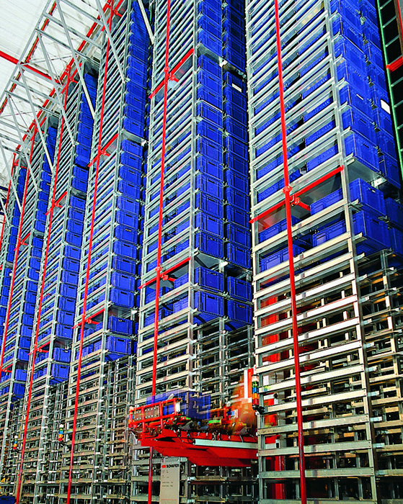

Edited by:
WIKA Alexander Wiegand SE & Co. KG
André Habel Nunes
Marketing Services
Alexander-Wiegand-Straße 30
63911 Klingenberg/Germany
Tel. +49 (0)9372 132-8010
Fax +49 (0)9372 132-8008010
a.habel-nunes@wika.de
www.wika.de

WIKA press release 07/2012

