New adapter system for sterile processes

Klingenberg, February 2012.
WIKA has now developed a process adapter system for measuring instruments with hygienic connections, which meets the high requirements of sterile engineering processes. It consists of a pressure gauge or transmitter with a mounted adapter and is certified to 3-A Sanitary Standards.

The flexible, modular system enables the connection of a wide range of aseptic process connections such as clamp, threaded, VARIVENT® or NEUMO®. All parts are manufactured from 316L stainless steel. The O-ring for sealing the process (optional), available in EPDM or FKM, is approved by FDA, USP Class VI and 3-A 18-03.

With this adapter system, customers can switch to measuring instruments with different process connections in a very short time. Therefore they can reduce long downtimes and inventory costs.

Number of characters: 858
Key words: Process adapter

Manufacturer:
WIKA Alexander Wiegand SE & Co. KG
Alexander-Wiegand-Straße
63911 Klingenberg
Tel +49 9372 132 – 0
Fax +49 9372 · 132 – 406
E-Mail Vertrieb@wika.de
www.wika.com

WIKA company photograph:
Fig. top: Pressure transmitter model S-11 with G1 hygienic connection
Fig. centre: Process adapter VARIVENT®
Fig. bottom: Clamp process adapter

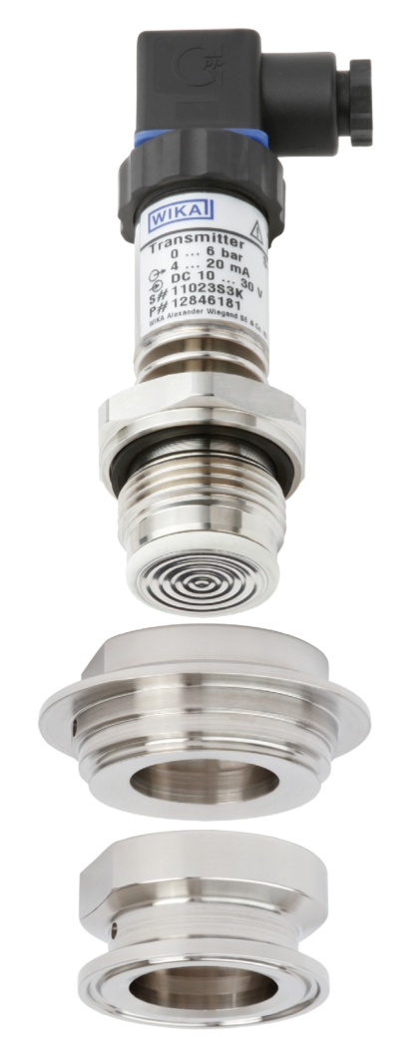

Edited by:
WIKA Alexander Wiegand SE & Co. KG
André Habel Nunes
Marketing Services
Alexander-Wiegand-Straße 30
63911 Klingenberg/Germany
Tel. (+49) 9372 132-8010
Fax (+49) 9372 132-8008010
E-Mail a.habel-nunes@wika.de
www.wika.de

WIKA press release 06/2012

