New resistance thermometer:
Space-saving and hygienic

Klingenberg, March 2010.
Wika has expanded its product range for sanitary applications with an exceptionally compact resistance thermometer with integrated transmitter. The hygienic TR21 Minitrans, with a diameter of 19 mm, enables space-saving installation, whether directly or within a thermowell.

The new thermometer operates in the range between –50 °C and +150 °C, and the span can be increased to +200 °C using an optional neck tube. The electrical connection is simple to make via an M12 connector, with the measured value transmission via a 4 ... 20 mA output signal of the transmitter. The measured value can, however, also be taken directly from the sensor (Pt100 Class A), without the transmitter it is even more space-saving.

For direct installation the thermometer is available with all established process connections. In combination with model TW22 or TW61 thermowells the instrument can be calibrated or exchanged without opening the process. Any possible contamination is therefore prevented. For hygienic design, WIKA follows the requirements of EHEDG and the 3-A® Sanitary Standards.

Number of characters: 1151
Code word: TR21 Minitrans

Manufacturer:
WIKA Alexander Wiegand SE & Co. KG
Alexander-Wiegand-Strasse
D-63911 Klingenberg
Tel. +49 · 9372 · 132-0
Fax +49 · 9372 · 132-406
E-Mail sales@wika.de
Internet www.wika.de

WIKA company photograph:
Resistance thermometer TR21

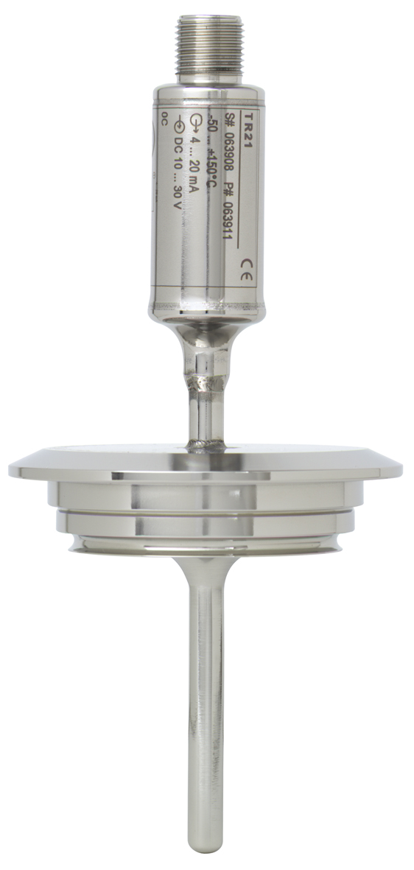

Edited by:
WIKA Alexander Wiegand SE & Co. KG
André Habel Nunes
Marketing Services
63911 Klingenberg, Germany
Tel +49 · 9372 · 132-806
Fax +49 · 9372 · 132-423
E-Mail a.habel-nunes@wika.de
Internet www.wika.de

WIKA press release 04/2010

