WIKA acquires Scandura

Klingenberg, January 2012.
With the acquisition of Scandura, WIKA has taken a further step to strengthen its leading role in the field of calibration technology.

Scandura, founded in Italy in the 1950s, from the start established itself internationally as a manufacturer of special calibration applications.

The portable calibrators, in particular, meet the highest demands and safety standards, and they offer reliable measuring equipment (for example with ATEX certificates and for critical applications in the process industry). The complete calibration systems enjoy a special reputation as well. Calibration software rounds out the portfolio.

Scandura will be integrated into the calibration technology division of the WIKA Group.

Number of characters: 753
Key words: Acquisition of Scandura

Manufacturer:
WIKA Alexander Wiegand SE & Co. KG
Alexander-Wiegand-Straße
63911 Klingenberg
Tel +49 9372 132 – 0
Fax +49 9372 · 132 – 406
E-mail sales@wika.de
Internet www.wika.de

WIKA company photograph:
Portable calibrator "Pascal ET/IS"

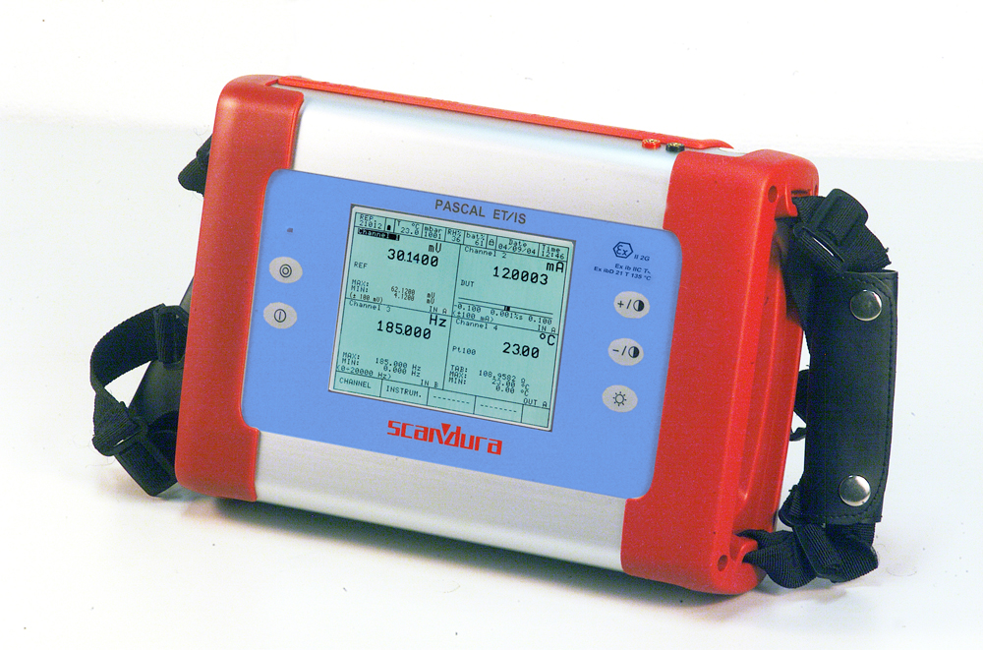

Edited by:
WIKA Alexander Wiegand SE & Co. KG
André Habel Nunes
Marketing Services
Alexander-Wiegand-Straße 30
63911 Klingenberg/Germany
Tel. (+49) 9372 132-8010
Fax (+49) 9372 132-8008010
E-mail a.habel-nunes@wika.de
www.wika.com

WIKA press release 02/2012

