Electronic pressure measurement:
WIKA blog answers questions

Klingenberg, November 2011.
A source for practically-oriented information and tips on electronic pressure measurement has sprung up online with WIKA: in a blog with the address
www.pressuresensor-knowhow.com.

Here, the product managers from the relevant division write short articles on themes with which they are most-frequently confronted on a daily basis. Users can find useful information on the fundamentals of electronic pressure measurement, on products and directives; and can get help and guidance with regard to application and product. To expand this "knowledge base", the authors also appreciate comments and suggestions for topics. Anyone who always wants to be up-to-the-minute with information can subscribe to the blog on an RSS feed.

Number of characters: 809
Key word: Blog

Manufacturer:
WIKA Alexander Wiegand SE & Co. KG
Alexander-Wiegand-Straße
63911 Klingenberg
Tel +49 9372 132 – 0
Fax +49 9372 · 132 – 406
E-mail sales@wika.de
Internet www.wika.de

WIKA company photograph:
WIKA blog, address: www.pressuresensor-knowhow.com

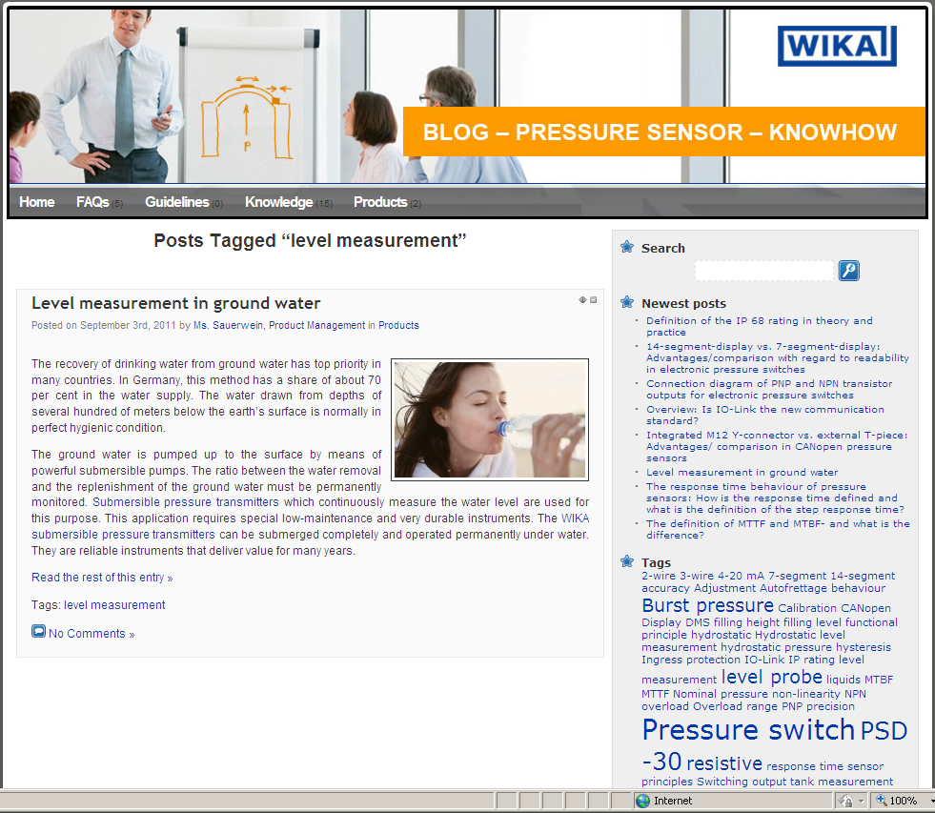

Edited by:
WIKA Alexander Wiegand SE & Co. KG
André Habel Nunes
Marketing Services
63911 Klingenberg
Tel +49 9372 · 132 - 8010
Fax +49 9372 · 132 - 8008010
E-mail a.habel-nunes@wika.de
Internet www.wika.de

WIKA press release 02/2011

