Hand-held pressure indicator
now with integrated pressure generation

Klingenberg, February 2010.
With the compact, new WIKA CPH6600 hand-held pressure indicator, a pressure calibrator with an integrated pump is now available to users within the process industries.

Since an external hand pump is not required, calibration tasks can now be carried out easier and quicker. The new hand-held generates pressures of up to 10 bar with an integrated electrical pump, manually up to 20 bar is possible. It operates with a high accuracy of ± 0.025 % FS.

The range of application of the new CPH6600 is expandable, e.g. for pressures up to 700 bar, through the connection of an appropriate external module. In addition, in combination with a temperature sensor a simultaneous temperature measurement is also possible with the calibrator. Additional functions, such as pressure switch testing and the display of test sample deviations in percent, increase the user-friendliness of the CPH6600.

Despite the extensive technical capabilities, due to its ergonomic form and a weight of under a kilogram, the CPH6600 is not at all cumbersome. The functional design and a large LCD display endorse the ease of use.

Number of characters: 1193
Code word: CPH6600 Hand-held pressure indicator

Manufacturer:
WIKA Alexander Wiegand SE & Co. KG
Alexander-Wiegand-Strasse
D-63911 Klingenberg
Tel. +49 · 9372 · 132-0
Fax +49 · 9372 · 132-406
E-Mail sales@wika.de
Internet www.wika.de

WIKA company photograph:
CPH6600 Hand-held pressure indicator

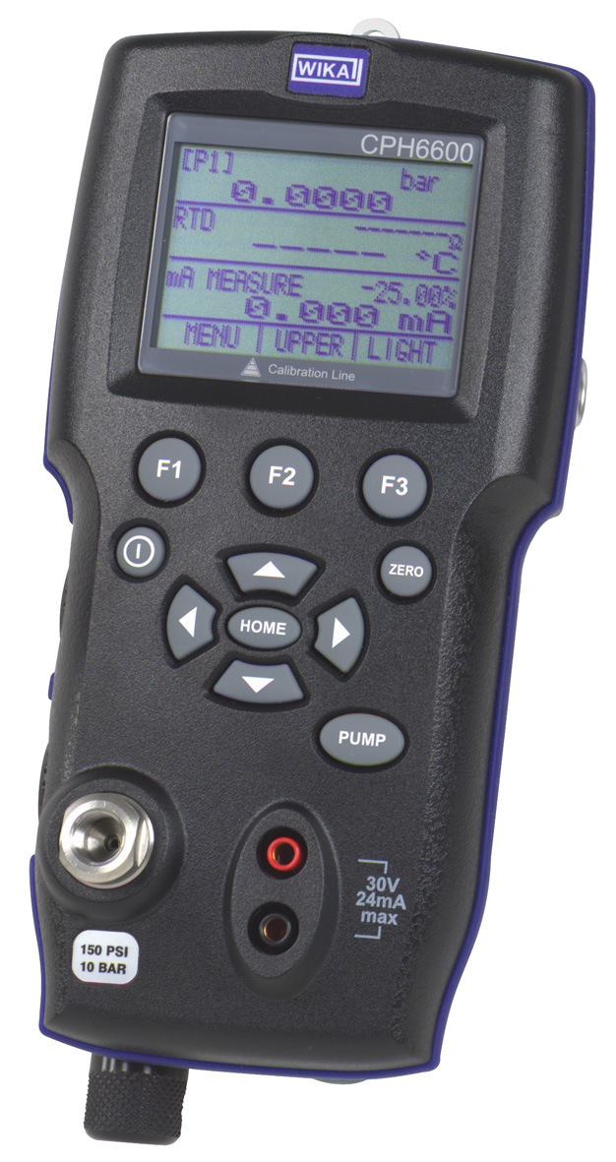

Edited by:
WIKA Alexander Wiegand SE & Co. KG
André Habel Nunes
Marketing Services
63911 Klingenberg, Germany
Tel +49 · 9372 · 132-806
Fax +49 · 9372 · 132-423
E-Mail a.habel-nunes@wika.de
Internet www.wika.de

WIKA press release 02/2010

